**Memo**

**Senior Design**

ENG EC 463

To: Professor Pisano

From: Michael Ethier, Solomon Utain, Ami Vyas, Alexander Wang

Team: 3

Date: 03/29/17

Subject: Functional Deliverable Test Plan

**Requirements Summary:**

Our DOSI probe differs from existing probes with its use of miniaturized components as well as the ability to output four different wavelengths of light through a single source, and a detector that has increased sensitivity at the proper range of wavelengths. The source in our optode is a newly designed and manufactured 4-wavelength VCSEL and the detector is a miniature Avalanche Photodiode (APD). There are several requirements below given to us by our customer that should be met in order to make the project is a success:

1. APD PCB Board
   1. Isolation of APD from bulky parts without introducing excessive noise
      * *Solved by*: placing APD on edge of board with filters close as possible on other side, but bulky parts far away
   2. Impedance matching
      * *Solved by*: Making traces appropriate widths, calculated with a computer program
2. VCSEL PCB Board
   1. Follow ANSI laser safety standards
      * *Solved by*: creating housing to shield laser output from eyes
   2. Reliably outputs all four wavelengths
      * *Solved by*: finding appropriate sturdy connectors for the laser connections
3. Optode Pair
   1. Precision: <5% Drift over 2 hours
      * *Solved by*: Drift test - taking the same measurement every minute for 60 minutes to see if the results are consistent
      * Will be reported on but not done during testing (takes 1 hour, then additional processing time)
   2. Accuracy: <10% error compared to current “gold standard” benchtop system
      * *Solved by*: Phantom sweep test - testing on about 20 different phantoms to see the ability of the probe to measure different tissue types
      * Will be reported on but not done during testing due to time constraints
   3. Signal-to-noise ratio 10:1 from 50-500 MHz
      * *Solved by*: finding voltage level and switch settings which optimize signal-to-noise ratio
   4. Voltage Conversion
      * *Solved by*: AC-DC converter and low-high DC-DC voltage converters as separate but attached units
4. Housing
   1. Can hold source and detector flush with the surface
      * *Solved by:* mounting holes on PCBs and holding VCSEL board deeper in than the APD board
   2. Secures all associated cables/wires
      * *Solved by*: Appropriately sized holes in housing and secure connectors
   3. Material safe to use with high voltages in PCBs
      * *Solved by:* ABS
5. Software
   1. Must be HIPPA compliant
      * *Solved by*: Hosted locally on a lab machine, not accessible over a network
   2. Classify data into separate and confidential patient records
      * *Solved by*: Autonomous tag extraction from data files and association with files, implementation of search functionality for clinicians to search through data

**Significance:**

This deliverable will show our product in its complete functionality. The VCSEL PCB board with secure connectors and a housing, APD PCB board design to our specifications, the voltage conversion, and the software component of the project with automated tagging will be tested together as one system. A few different tests will be performed and the results will be processed for the test report to show if the product meets customer accuracy and precision requirements.

**Testing Setup - Hardware:**

Place the VCSEL into the VCSEL PCB and make sure that the ground pin on the VCSEL lines up with the top pin on the VCSEL PCB. Connect the current controller to **the** biased T and then connect the biased T to both the **VCSEL** PCB and the RF switch. Make all of these connections using RF connectors. Do this for all 4 wavelengths. Supply 5 V DC to the RF switch. Make sure the evaluation board switches are in the Low Gain, DCFB on configuration. These switch settings correspond with the table below. Make sure all of the USB connections are in place and the computer is running in 32-bit mode for LabView control of components. Make sure that output 1 for the evaluation board is connected to Port 2 on the network analyzer using an RF connector. Connect the output from the high voltage converter to the high voltage input on the APD PCB. Ensure that all of the voltage converters are connected, and plug the AC to DC converter into an outlet to power the system. Referring to the diagram below for the high voltage converter PCB, input pin 5 should be connected to the 12V DC output from the AC to DC converter. Input Pins 4 and 7 should be connected to the output of the 5V DC to DC converter. Input Pins 3, 6, and 8 should all be connected together, while Input Pins 1 and 2 should be grounded. Additionally, the inputs for both the 3.3V DC to DC converter and the 5 V DC to DC converter should be connected to the 12V output of the AC to DC converter. Finally, the output of the 3.3V DC to DC converter should be connected to the low voltage input of the APD PCB.

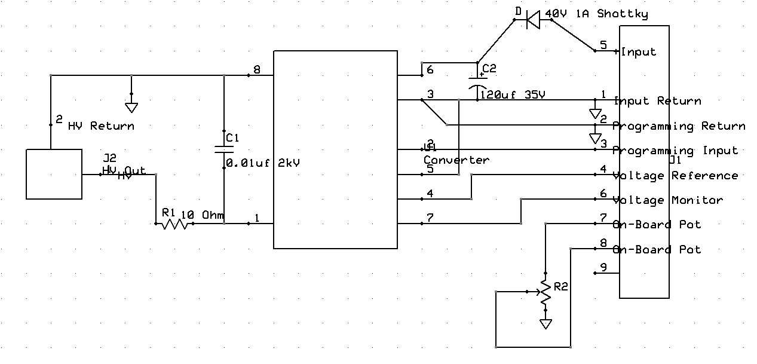

High Voltage Converter Schematic

For the network analyzer, change measurement to S21 and autoscale the graph. The start and stop frequencies are set to 50 MHz and 500 MHz with a 6 dBm power limit. On the current supply, the current for the lasers should be 10,15, 5 and 10 mA for the 660, 680, 775, and 795 nm lasers respectively.

On the computer, open the DOS System -> Benchtop DOS System -> Senior Design to open the LabView system. Enable saving, and input a file name and ID. Hold the VCSEL so it outputs into the phantom. Raise the phantom platform so that the mounted APD is flush onto the surface of the phantom near the VCSEL with a source-detector separation of 10mm. Input this separation into the LabView program. Make sure that both the VCSEL and APD are near the center of the phantom because near the edges the light scatters in a different way which is not ideal for testing. Finally, hit the “Take Measurements” button to start the measurements.

*SNR Testing*

To meet the requirement of a 10:1 signal to noise ratio, we must take both signal and noise measurements using our current setup. The signal measurement should be taken using the setup described above, preferably on the Acrin 009 phantom, which simulates breast tissue. Next, take noise-floor measurements by placing the VCSEL flush onto a piece of rubber which allows no light scattering. These two measurements should be divided across the frequency range and an SNR plot of SNR vs. Frequency can be created. If the signal to noise ratio is above 10 (20 dB) for most or all of the frequency range, the requirement has been met.

*Precision Testing*

To meet the requirement of >95% precision for the probe, a drift test should be conducted. This requires the same measurement to be taken on the same phantom with the same settings (nothing changed) every minute for an hour. The settings we will use are described above, using the ACRIN 009 or INO 09 phantoms. If the measurements taken in the 60 minute period do not differ from each other by more than 5% of the initial value, the requirement has been met. This test will not be conducted during the testing period due to its length. The data for this test will be processed by a graduate student in our customer’s lab and reported in the test report.

*Accuracy Testing*

To meet the requirement for >10% accuracy, a phantom sweep test must be conducted. This requires the same measurement, with the settings detailed above, to be taken on an entire phantom set. This will parse about 20 or more phantoms. The scattering and absorption coefficients that can be found using the collected data will be compared to the known values and if the values are within +-10% of the standard, the requirement will be met. This test will not be conducted during the testing period due to its length. The data for this test will be processed by a graduate student in our customer’s lab and reported in the test report.

**Testing Setup – Software:**

As with the final installed system, this setup assumes data files have been transferred to the machine hosting the database and placed within the root directory containing the database. Automated tag association is carried out by running a Python script, and search queries are carried out via bash commands. For the former, results are to be verified via bash commands. The test machine is running a x64 version of Debian 8 with necessary packages installed to host the database as well as a semantic file system and run Python scripts.

*Automated Tag Association*

This test will be performed within a directory containing thousands of data files acquired by our senior design group, as well as patient-anonymous clinical data. Running a tag association script will look for data files in the directory containing the script as well as all subdirectories. Once tags are associated, results will be verified by displaying a list of files catalogued in the database, a list of tags, a list of values, and displaying the tags and values associated with a small sample of files.

*Search Queries*

This test will be performed after the automated tag association test. Search queries will be performed using bash commands over the command line interface. Tags, values, multiple tags and values, and exclusions of tags and values (I.e. and, and not), and quantifiers of values (I.e. >, <, =) can be set as search filters. Query results will be displayed within the file system, accessible as links to the real files. To verify results, query results will be accessed and shown to match the query itself.